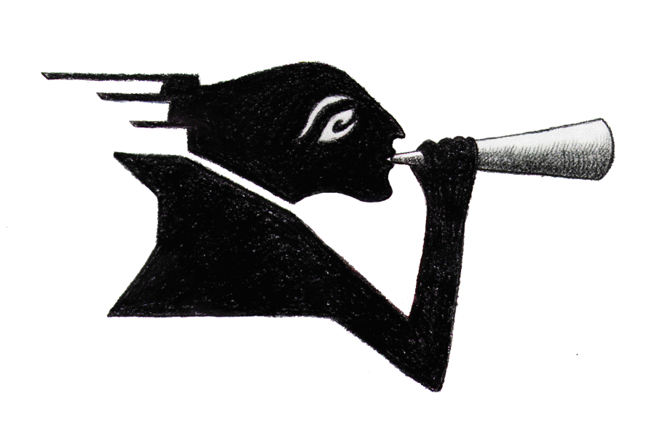
Press Contact: Melvin Yen
Messenger
Theatre
Co.
nyao.yen@gmail.com
(929) 261 - 9560

For Immediate Release:
On February 8th, Messenger Theatre Company will launch its second audio drama podcast series, The Defense.
Recorded live with an audience at Jalopy Theatre in Brooklyn, The Defense features a cast of all women and a majority of women on the creative team. New episodes will be released on Thursdays.
In the World Premiere of The Defense, five women, with a unique ability to defend against predators, meet once a week to support each other. In this dramedy, each woman has a different power, some deadly, some comic, to keep her safe. Bria’s defense stops hearts. Leila’s defense drops objects on heads. Mari’s defense turns predators to ash. Lori’s defense makes men doll sized. Kacey keeps the group together. Episodes 5 – 8 will be recorded on February 11. Episodes 9-12 will be recorded on March 10 and Episodes 13-16 will be recorded April 14. Tickets are $10 and available at Jalopy Theatre.
The Defense is written and directed by Emily Rainbow Davis (Artistic Director, Messenger Theatre Company) and features sound design by Matt Powell (The Dragoning, The Chip) and music by Scott Ethier (Richard Rogers Award). Actors include: Marcella Adams, Amber Jessie, Cosmic Kitty, Kristen Vaughan (thrice nominated for the New York Innovative Theater Award) and Toni Watterson. Stage management by Ella Lieberman. Produced by Melvin Yen.
The previous audio drama, The Dragoning, charted in the drama and fiction charts of Russia (#21), Sweden (#27), Germany (#36), Australia (#52), Denmark (#71), Canada (#74), New Zealand (#85), United States of America (#85), India (#111) and Great Britain (#127).
Podcast Magazine described The Dragoning as, “a lot of interesting social commentary and twists around how women might use their newfound power.” This is true of The Defense, as well.
Listener Reviews of The Dragoning posted on Apple Podcasts

The Dragoning is on fire! For all those women (and cool men) out there who have long fantasized about roasting the worlds’ dude bro’s, this series is for you! - Furious Snowcat

Very entertaining and yet incredibly timely and thought provoking! Can't wait for the next episodes! - UWS 191

